Junior Producer (Account Executive)
REPORTING TO: Producer (Senior Account Manager)
WORKING HOURS: Monday – Friday, 9.00/10.00 – 18.00
LOCATION: Holborn Studios, Eagle Wharf N1, London
AREA OF RESPONSIBILITY: Client servicing, creative and media analyst briefing
KEY INTERNAL INTERFACES: Media/analysts, creative, editors, campaign managers
KEY EXTERNAL INTERFACES: Clients, media agencies, call centres
SALARY: £26-£28K (DOE)
A bit about DTV
We are direct marketing fundraisers who help NGOs acquire new donors through direct response television, film, and radio. We help to inspire current donors to continue to keep giving. We use film to recruit major donors. We work with media agencies and call centres to help NGOs manage response effectively and get
the best deals possible. DTV is now an employee-owned trust (EOT).
DTV London is our HQ, we also have offices in Hong Kong, Sydney, Seoul, and Vienna, serving our International NGO's who are based around the globe.
You’ll become a vital part of our vibrant and friendly producer (account management) team and build strong relationships across every area of the
agency including Creative, Post-production, and Media.
What are we looking for?
We are global leaders in what we do because we have our own ways of doing things: a simple but clever business model, a strong sense of business ethics and some very smart people. We are looking for someone who shares our values and brings the skills and experience to get going straightway. Variation in workload is part of life at DTV and we’re looking for someone who can step in to help at our busiest times.

You may be a recent graduate or looking for a career change and up for a new challenge. Your background will show an appetite for marketing and advertising, and you’ll have a passion for wanting to help make the world a better place.
We are serious about encouraging diverse talent and welcome applications from
all backgrounds.
What skills will you need to shine?
We need a safe pair of hands for our clients to reply on. You’ll understand that the detail is all important and you’ll be eager to learn everything film-related within the direct marketing world.
You’ll get solid training to give you a great grounding in all that we do, and if you can already demonstrate these skills then you’ll grow even quicker:
- Project Management skills. You’ll be efficient, organised, articulate, convincing and team-minded, able to think ahead, plan for what’s coming up and meet deadlines, providing regular reports & updates.
- Communication skills. You’ll need excellent communication skills to influence people across DTV (creative, media, analysts …) and externally (your clients) to help bring people together and stay on schedule. You’ll need to be flexible and able to deal with a multitude of people, personalities, and priorities.
This experience would be helpful
- Direct Marketing. Understanding the basic principles of direct marketing is key. You’ll be able to show us that you’re numerate and enthusiastic about understanding campaign performance. Of course, we’ll train you in the detail and specifics… we just need you to show us that you have a passion for success and numbers.
- Creative and production. TV ads and film are our core outputs. You’ll be the kind of person who wants to learn how to brief and develop great creative that works.
- Fundraising. It would help you understand and have empathy with the charity sector.
And what will you get out of this?
Great training from day one, and responsibility quickly. Fairly flexible working hours, very generous holidays (DTV Long-weekenders: one Friday off per month).
Being part of the DTV Group is a friendly, supportive and exciting place to be. We’re growing and extending our offering around the globe and into the digital space by creating and delivering other types of film and video.
There is always lots to learn, and you’ll be up to speed quickly with our support. You’ll enjoy fairly flexible working hours, very generous holidays including the much-loved DTV Long-weekends (one Friday off per month). Lots of team socials which endeavour to respect your life outside work.
We’re combining office and remote working to get the best of both worlds.
DTV is dog-friendly to say the least. Visit our Instagram to meet all our furry friends @dogsofdtv You can also find us humans @whateverinspires.dtv
We’re delighted to offer this opportunity to be part of not just a fast-growing agency in an exciting market, but an agency that is a world leader in fundraising DRTV.
To apply, send your CV and covering letter to jobs@dtvgroup.co.uk. Please make sure only to include mobile number in your CV and cover letter removing any identifiers such as name, date of birth and email address, which will be forwarded to the relevant hiring manager.
DTV is committed to providing an inclusive and creative environment for everyone to thrive, whatever our background or identity. We enjoy an ongoing and inspiring program of events to celebrate diversity and difference and ensure all our managers are trained in overcoming unconscious bias. Please send your application without name, age or any other non-work-related details and if you need specific arrangements at interview just let us know and we’ll work around you.

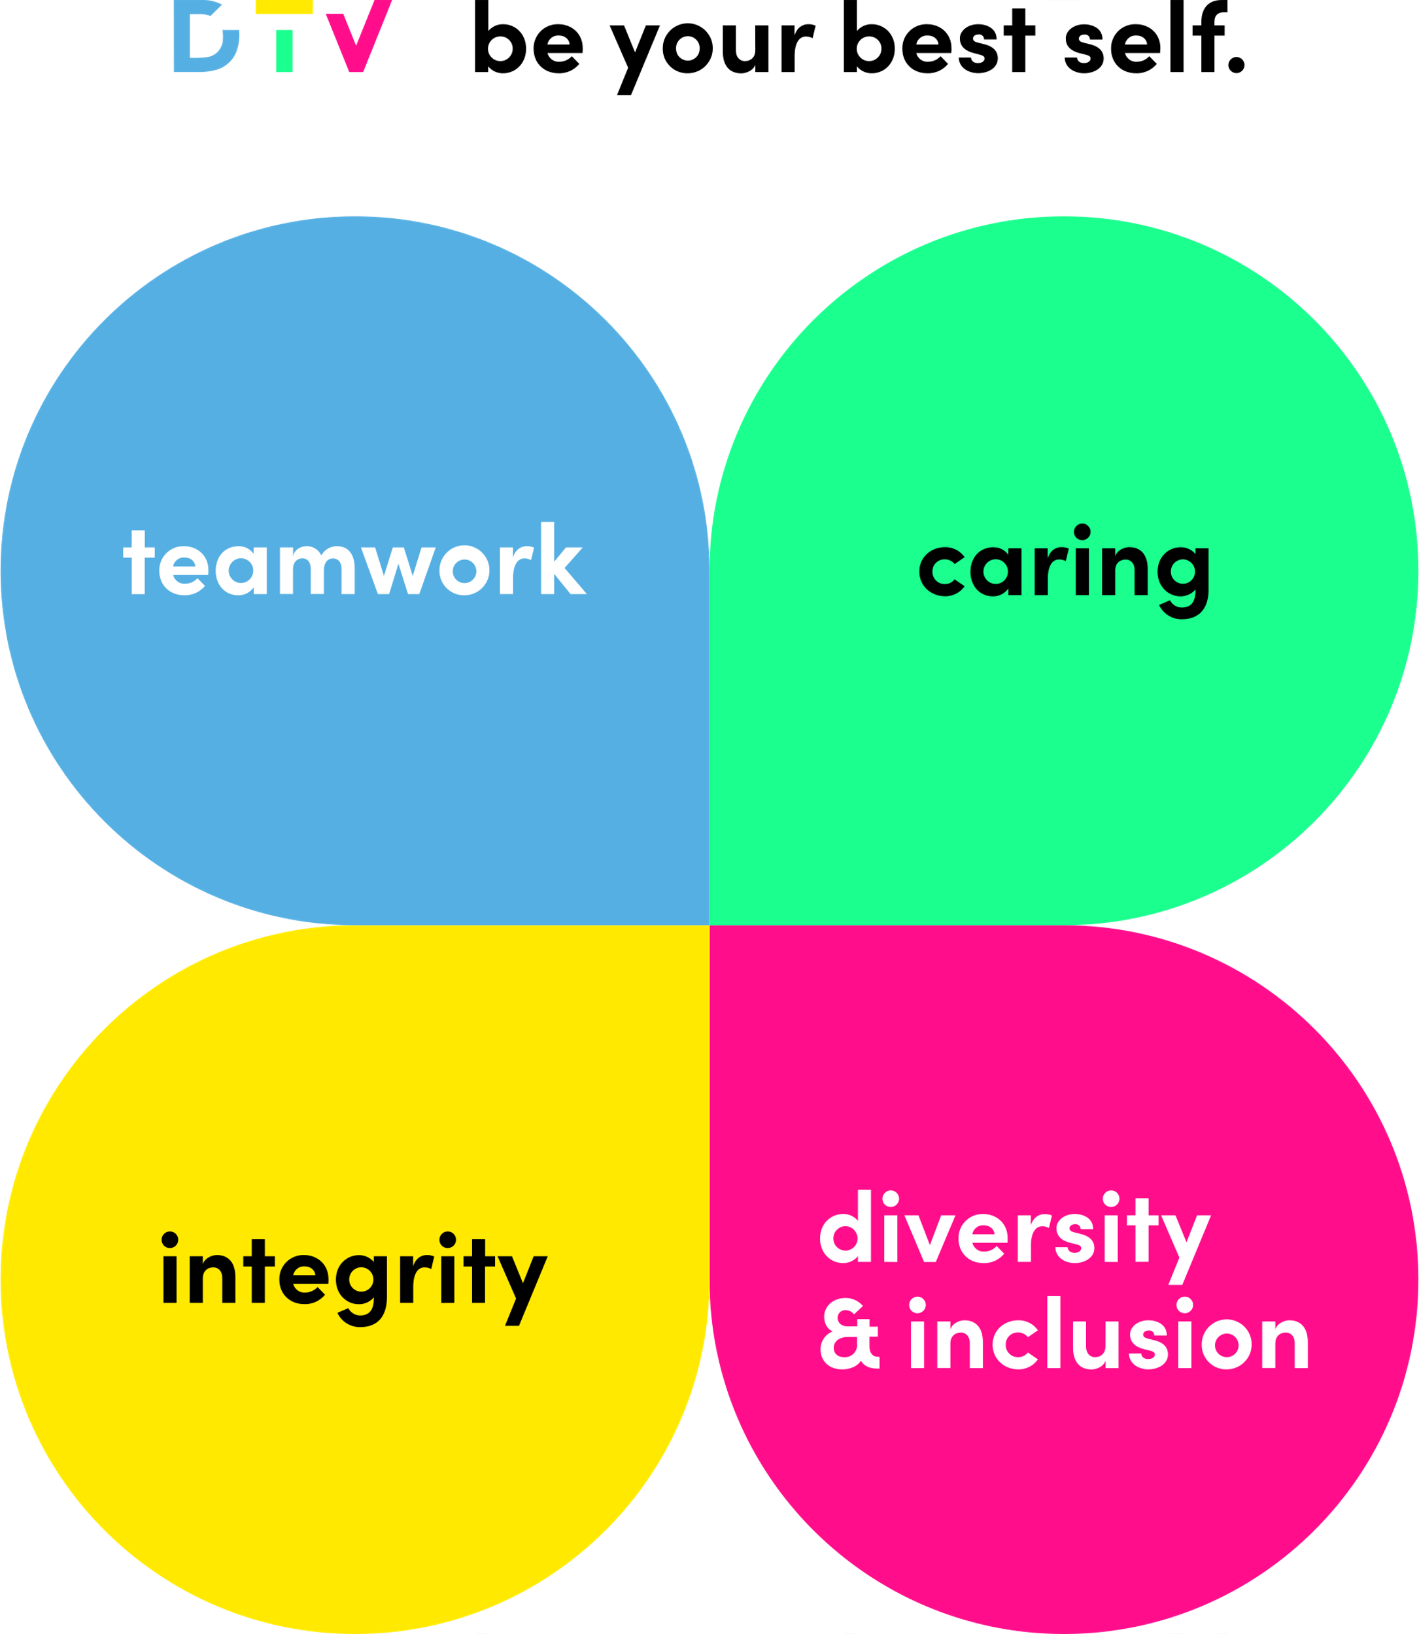 | Be your best self.  When we bring these values to life every day and in everything we do, we’ll be able to show up not only as ourselves at work, but our BEST selves.

